Application Form
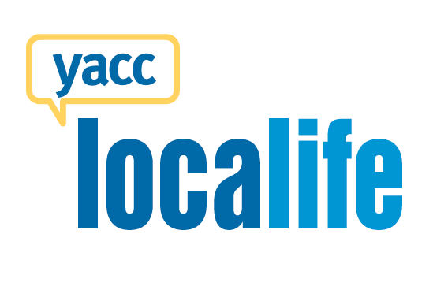
Full Name: DOB (mm/dd/yy): Age:
Are you a cancer survivor or supporter? ___ Survivor ___ Supporter

Which gender do you identify with?: ___ F ___ M
How old were you (or your loved one) when you (they) were diagnosed with cancer?
When did you (or your loved one) complete treatment? (mm/yy)
Have you attended Localife events? ___ Y ___ N If yes, when was your first event?
Have you ever attended a YACC event (e.g., Retreat Yourself; Survivor Conference, etc.)? ___ Y ___ N
If ‘Yes’, please tell us which event and which year you attended:
If ‘No’, please provide us with a reference (If possible, please choose a reference who has a professional role related to cancer – e.g., social worker, nurse, oncologist, someone who works at a cancer organization; support group coordinator, etc.)

Full Name: Organization/Institution:
Role: Phone #: Email:
How long has this person known you?
Are you able to commit ~10-15hrs/event to being a Localife Leader from Nov 2017 to June 2019? Events usually occur every second month, on average. __ Y __ N
Do you have an educational/professional background in one of the following areas? (check all that apply)
___ Recreation Therapy | ___ Social Work | ___ Nursing
___ Psychology/Counselling | ___ Health Promotion | ___ Camp Counsellor
___ Art Therapy  ___ Event Planning | ___ Volunteer Coordination | ___ Digital Media

Please Note: It is very important that we can read your responses If you are unable to type your responses, please ensure that your handwriting is neat and legible. The space allotted for responses is a suggestion. Feel free to type more or add additional pages when necessary.
1. Please tell us a bit about your cancer experience (1 – 2 paragraphs; e.g., diagnosis, treatment (type/ length), where you received treatment; relapse?; how it impacted your life, major challenges, major sources of strength, etc.).

2. It is important that our Localife Leaders are in a place of peace and acceptance with their personal cancer experiences. Please tell us about some of the key experiences you’ve had that have contributed to your healing process and have inspired you to give back to your young adult cancer peers.

3. Please tell us a little bit about what you’re up to these days (e.g., time commitments related to school, work, family, adventures, volunteering, etc.).

4. How, if at all, have you been involved in giving back to the young adult cancer community (e.g., volunteering, raising public awareness, fundraising, etc.)?

5. The major focus for this position will be coordinating Localife – an activity-based program that involves bringing young adult cancer survivors/supporters together to enjoy fun activities and social time. It involves working independently and taking initiative in planning/promoting events. Examples of Localife activities include movie night, curling, hiking, etc. Please tell us why you think you’d be great at coordinating Localife (e.g., group facilitation skills; recreation interests/skills; outgoing personality; organizational skills; computer skills; social media skills; etc.).

6. We will also be asking our Localife Leaders to build and nurture relationships between YACC, health professionals, and the larger community. This may involve reaching out to health professionals to tell them of our programs, or helping out with our annual fundraiser (the Shave for the Brave or the Climb). Please tell us why you think you’d be great in this role (e.g., well-connected in your community; fundraising experience, etc.).

7. It can be challenging to build a sustainable peer support community, with regular attendance for activities. What are some strategies you could use to a) get the word out about Localife to survivors and supporters in your city and b) keep people interested and connected to the group?

8. For the most part, Localife events mostly happen on weekday evenings or any time during the weekend. Knowing that, we do try and accommodate Leader’s personal schedules as much as possible. Do you forsee any challenges in this, for example, do you work every weekend? Do you always work weekday nights?

Contact Information:
Phone Number:
Email Address:
Mailing Address:

Which city are you applying to be a leader?
___ Victoria (Vancouver Island) ___Vancouver ___Winnipeg ___St. John’s

How did you hear about this leadership opportunity?
_____ Email from YACC
_____ Facebook
_____ YACC website
_____ Health Professional (Who was it? _________________________________)
_____ Other (Please specify: ___________________________________________)

Please return completed application forms, along with a resumé to Lesley Morrissey by
Monday, Nov. 6, 2017
By email: lesley@youngadultcancer.ca
By fax: (709) 579-7326

